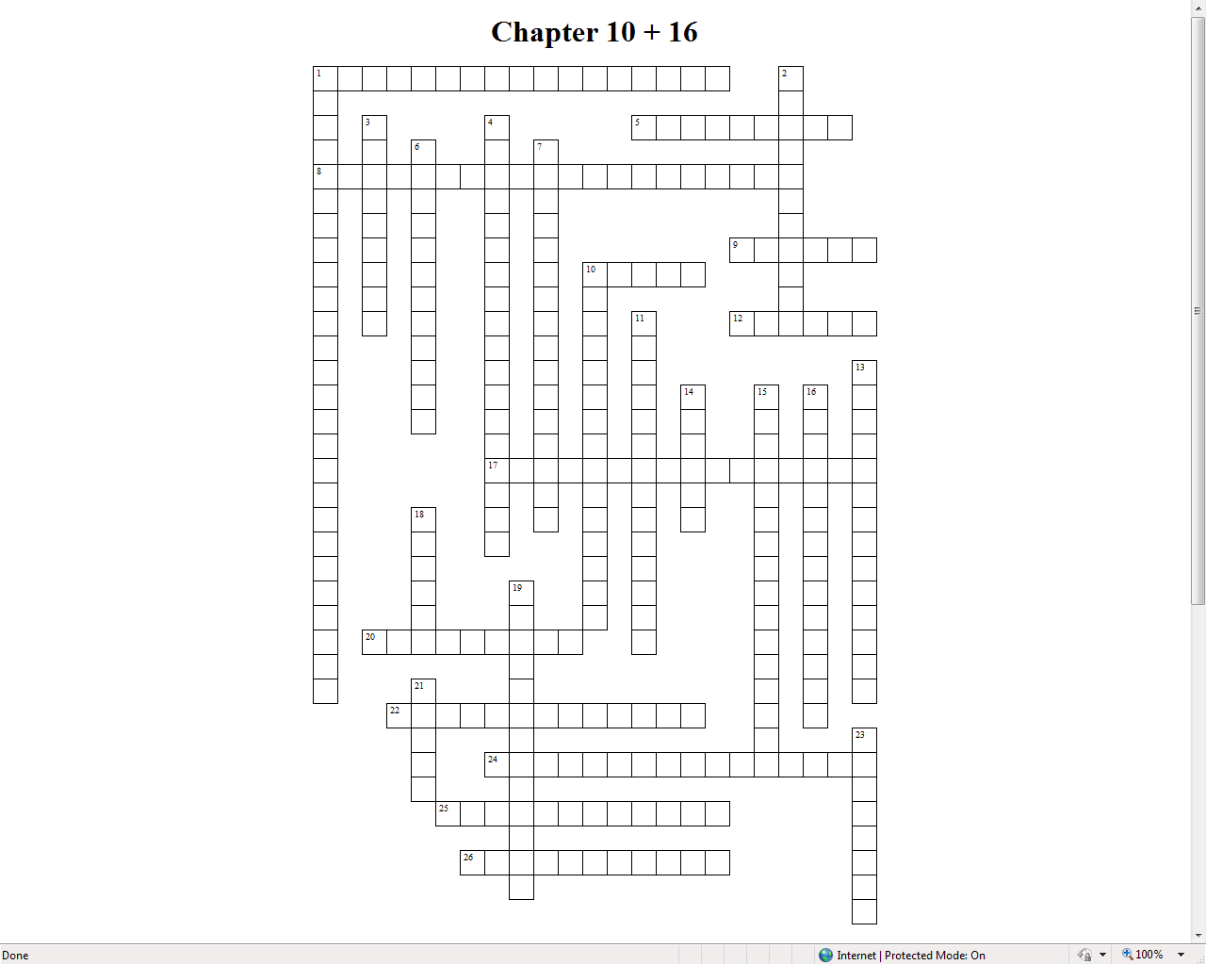Unit of value #2 down

|  |  |  |  |  |  |  |  |  |  |  |  |  |  |  |  |  |  |  |  |  |  |  |  |  |  |  |  |  |  |  |  |  |  |  |  |  |  |  |  |  |  |  |  |  |  |  |  |  |  |  |  |  |  |  |  |  |  |  |  |  |  |  |  |  |  |  |  |  |  |  |  |  |  |  |  |  |  |  |  |  |  |  |  |  |  |  |  |  |  |  |  |  |
| --- | --- | --- | --- | --- | --- | --- | --- | --- | --- | --- | --- | --- | --- | --- | --- | --- | --- | --- | --- | --- | --- | --- | --- | --- | --- | --- | --- | --- | --- | --- | --- | --- | --- | --- | --- | --- | --- | --- | --- | --- | --- | --- | --- | --- | --- | --- | --- | --- | --- | --- | --- | --- | --- | --- | --- | --- | --- | --- | --- | --- | --- | --- | --- | --- | --- | --- | --- | --- | --- | --- | --- | --- | --- | --- | --- | --- | --- | --- | --- | --- | --- | --- | --- | --- | --- | --- | --- | --- | --- | --- | --- | --- |
| |  |  |  | | --- | --- | --- | | **ACROSS** | | | | **1** |  | System where banks hold in reserve a portion of their funds, just enough to meet their customers’ daily needs | | **5** |  | Money that has alternative use such as gold, silver, oil, corn, wheat, cotton, etc “order or decree” government issued money | | **8** |  | The amount of money that is required for the bank to hold for each deposit | | **9** |  | The combination of all stores of value; both money and nonmonetary assets is a person’s | | **10** |  | Are the assets people use to buy goods and services | | **12** |  | The nickname for the federal reserve | | **17** |  | The Federal Reserve was established in this year | | **20** |  | Appointee board members by the | | **22** |  | The process by which money enters into circulation | | **24** |  | Interest rate banks charge each other for loans | | **25** |  | Money keeps its value if you decide to store it instead of spend it | | **26** |  | The total quantity of money in the economy is the | |  | |  |  |  | | --- | --- | --- | | **DOWN** | | | | **1** |  | Makes key decisions about interest rates and the growth of the US money supply | | **2** |  | An expression of worth; a means for comparing the values of goods and services is money as a | | **3** |  | Represents the ease with which an asset (liquid asset) can be converted into money, or the medium of exchange | | **4** |  | U.S. dollar is formally referred to as this | | **6** |  | The rate for which the Federal Reserve charges loans to commercial banks | | **7** |  | Money serves as payment for products; buyers give sellers in exchange for goods/services | | **10** |  | Formula that indicates how much the money supply will increase after an initial cash deposit to the banking system | | **11** |  | Money that can be exchanged for something of value IOU, Paper Receipts, bonds, etc. coins and paper bills used as money | | **13** |  | Money that people can gain access to easily and immediately are known as | | **14** |  | An economy that relies on trade of one product for another | | **15** |  | The Federal Reserve System is overseen by this group of seven members | | **16** |  | Refers to Actions taken by the Fed to influence the economy | | **18** |  | The number of Federal Reserve Districts in the United States | | **19** |  | The process by which banks record whose account gives up money and whose account receives money when a customer writes a check | | **21** |  | These government securities are bought and sold in order to increase or decrease the money supply | | **23** |  | Current chairman of the board | |